ACT Government Public Art Guidelines

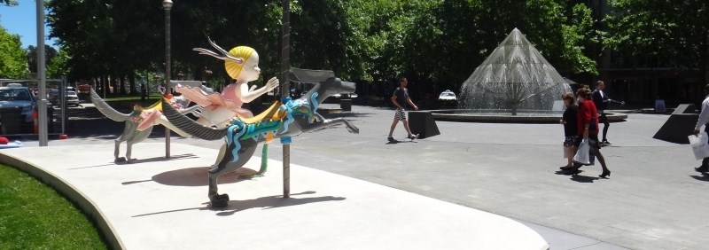

artsACT
Chief Minister, Treasury and Economic Development Directorate
June 2015 - Updated October 2021

Contact us
Postal Address: artsACT
Chief Minister, Treasury and Economic Development Directorate
ACT Government
GPO Box 158
Canberra City ACT 2601

Office Address: Level 3
220 London Circuit
Canberra City ACT 2601
Telephone: (02) 6207 2384
Email: artsACT@act.gov.au
Website: www.arts.act.gov.au

Cover Image: The Other Side of Midnight by Anne Ross and The Canberra Times Fountain by Robert Woodward, corner of City Walk and Ainslie Avenue, Civic.
For more information on these artworks, visit www.arts.act.gov.au/public-art/the-other-side-of-midnight and www.arts.act.gov.au/public-art/the-canberra-times-fountain

Accessibility
The ACT Government is committed to making its information, services, events and venues accessible to as many people as possible.
If you have difficulty reading a standard printed document and would like to receive this publication in an alternative format, such as large print, please telephone (02) 6207 2384.
If English is not your first language and you require the translating and interpreting service, please telephone 13 14 50.
If you are deaf or hearing impaired and require the TTY typewriter service, please telephone (02) 6205 0888.

Table of Contents
Section One: Introduction, Purpose and Context 5
Introduction 5
Purpose 7
Context 8
Roles and responsibilities 9
Section Two: Guidelines 13
ACT Government commissioned public art 13
ACT Government acquired public art 13
ACT Government commissioning and acquisition processes 14
Case study: The commissioning of Icarus 24
Case study: The acquisition of Life Boat/Thuyen Cuu Roi 25
Contract considerations 26
Plaques 29
Maintenance and collection management 30
Decommissioning 33
Case study: The decommissioning of LaserWrap 34
Donating public art to the ACT Government 35
Case study: The donation of the statue of Confucius 39
Other gifts of cultural significance 40
Case study: The gifting of Fenix 2 41
Memorials with an artistic element 42
Case study: The commissioning of the ACT Memorial 43
Private sector public art on ACT Government land 44
Case study: Resilience – a private sector and ACT Government collaboration 48
Private sector public art on private land 49
Case study: Time Thief – a private artwork commissioned for private land 50
Temporary and community art on ACT Government land 51
Case study: Sir Robert Menzies and the guerilla knitters 53
The ACT Public Art Database 54
Appendix A 55
Glossary of terms 55
Appendix B 58
Related policies and guidelines 58

Section One: Introduction, Purpose and Context

Introduction
Canberra is a vibrant community hosting exciting art in numerous public and private spaces – indeed, almost everywhere across our city. Much of this work is by talented local artists, many of whom are recognised and celebrated nationally and internationally, and we are proud to support their endeavours.
Art enhances our quality of life. The ACT Government believes access to and participation in the arts is vital to a productive, healthy, and creative community.
Public art plays a central role in reflecting our community’s values and history and inspires us with new stories and experiences. Art can be thought-provoking, challenging our perceptions. Art can help us to look differently at the everyday.
A public artwork may inspire one person and challenge the next, someone else may find it humorous and for another person it may be linked with a special remembrance. Each response is equally valid – because public art is for everyone.
Public art makes our open spaces more attractive and engaging. It enhances our experiences of public spaces and the people that inhabit them.
Canberra has developed a rich collection of artworks in the public domain. Public art is commissioned or acquired by the ACT and Australian Governments as well as diplomatic missions and community groups. The ACT is also fortunate to have universities and a private sector that embrace the benefits of public art and are active in commissioning high-quality works for both public and private spaces.
The ACT Government public art collection is owned by the community and reflects the value that the Canberra community places on the arts.
Some of our public art is site specific and reflective of an artistic interpretation of the world, while other works tell a story of Canberra’s history, such as the heritage-listed statue of Ethos in Civic Square, the whimsical Ainslie’s Sheep in the city centre - a satirical salute to one of Canberra’s early pastoralists, or the Tree of Knowledge at the Garran Shopping Centre.
Many works are an important legacy of local, national, and international artists who have contributed to both the fabric and identity of our city, and whose works continue to define and create a sense of destination for visitors and locals.
Canberra’s community is made up of a dynamic mix of people from diverse cultural backgrounds. This is reflected in public artworks such as the statues of Gandhi in Glebe Park and Confucius in Dickson.
Public art is a way of bringing communities together, such as the ACT Bushfire Memorial in Stromlo Forest Park and Patria es Humanidad in Latin American Plaza.
The ACT Bushfire Memorial was commissioned by the ACT Government to acknowledge the impact of the 2003 bushfires, to mark the process of recovery, and to thank the many organisations and individuals who played crucial roles in the fire fighting and recovery efforts. It was developed as part of an extensive community consultation process by Canberra artists Tess Horwitz, Tony Steel and Martyn Jolly.
Latin American Plaza is built around a dedicated sculpture walk of artworks donated by the Latin American community and is a meeting place for celebration and community activity.
Public art exists because of, and for, the Canberra community.
The ACT Government regularly commissions artists and acquires work to enrich Canberra’s built environment with public art. The 2015 ACT Arts Policy guides ACT Government support for and investment in the arts, and provides context for these ACT Government Public Art Guidelines.

Purpose
The purpose of the ACT Government Public Art Guidelines is to outline a consistent whole-of-government approach to the commissioning, acquisition, donation and management of public art in the ACT.
It contains guidelines covering the commissioning or acquisition of public art by ACT Government directorates; private sector art on ACT Government land; donations of public art to the ACT Government and other gifts of cultural significance; memorials with an artistic element; temporary and community public artworks; as well as helpful hints for privately owned public art on private land.
The ACT Government Public Art Guidelines aim to make the process of commissioning, acquiring and donating public art as straightforward and streamlined as possible for everyone involved. This aligns with the ACT Government’s focus on better connecting small and large businesses, community groups and individuals to Government directorates.

Context
The ACT Government Public Art Guidelines are guided by the principles of the 2015 ACT Arts Policy.

Scope
Artworks within the scope of the ACT Government Public Art Guidelines are:
- Public art assets of the ACT Government on public land and including loan items and public art with restricted access, such as Moai at the Legislative Assembly and The Meeting Place at the Alexander Maconochie Centre.
- Privately owned public art on ACT Government land.
- Privately owned public art on private land.
- Temporary and community public art.
- Memorials with an artistic element.
The following are outside the scope of these guidelines:
- Memorials that do not have an artistic element (e.g. plaques, roadside memorials).
- Fountains that do not have an artistic element.
- Architectural features incorporated as part of a larger building or landscape project or architectural ornamentation (e.g. railings, light fixtures, tiles).
- Moveable artworks displayed inside ACT Government buildings and facilities, referred to hereafter as the Indoor Art Collection. Each agency is responsible for their own indoor collection.
- Other moveable items of cultural significance that are not artworks, which are displayed inside ACT Government buildings and facilities.
- Public art owned by the National Capital Authority or other Australian Government agencies. The Australian Government, through the National Capital Authority, has Guidelines for Commemorative Works in the National Capital, which address public art planning issues for the areas under its jurisdiction.

Roles and responsibilities

ACT Government
The ACT Government plays a lead role in the development and management of public art in our community through a range of planning, commissioning, acquiring, and asset management activities. These activities are undertaken by several areas across Government.
Each ACT Government Directorate is responsible for commissioning, acquiring, and maintaining public artworks on behalf of their own agencies. This work should be undertaken in consultation with artsACT and other relevant stakeholders.
Each agency is responsible for its own Indoor Art Collection (see Glossary of Terms).

Chief Minister, Treasury and Economic Development Directorate:
artsACT is the ACT Government’s arts agency and is responsible for a significant number of public art assets across the ACT Government public art collection.
The ACT Government Public Art Guidelines have been developed by artsACT to provide a consistent whole-of-government approach to commissioning or acquiring public art, as well as its location, installation and signage and ongoing collection management, including decommissioning as necessary.
artsACT can assist other areas of the ACT Government, private and community sector organisations, businesses and individuals with expert advice in relation to public art proposals.
artsACT manages the ACT Public Art Database. All ACT Government public artworks should be listed in the database to ensure the Government’s public art collection is accessible to as many people as possible. Although there is no requirement to do so, artsACT can include private sector public artworks on the ACT Public Art Database.
The Policy and Cabinet Division provides advice to artsACT in relation to accepting donations and gifts of public art.
The National Arboretum Canberra and Stromlo Forest Park manages the Forest Sculpture Gallery (FSG) which is an art trail set amongst the 44,000 trees of the National Arboretum Canberra. The FSG is governed by an Advisory Committee which provides expert vision, advice, comment, and support to the Gallery in matters pertaining to the development, display, and management of the Collection. An external Curatorial Advisor is engaged to support the work of the Gallery. artsACT owns and maintains four large scale public artworks that form part of the FSG. All other artworks are assets of FSG. artsACT also owns and maintains the ACT Bushfire Memorial located Stromlo Forest Park.
Venues Canberra is a custodian of public art within its facility portfolio, including GIO Stadium Canberra, Exhibition Park in Canberra (EPIC) and Manuka Oval. GIO Stadium is home to the sculptures of Canberra sportsmen, Laurie Daley and Mal Meninga.

Education Directorate:
The Education Directorate is a significant custodian of public art across numerous sites. The Directorate engages artists to work in schools, often resulting in community art projects such as murals.
Many of the public art assets of the Education Directorate have restricted public access as they are located within the grounds and courtyards of the schools.

Environment, Planning and Sustainable Development Directorate:
Where required, Planning within the Environment, Planning and Sustainable Development Directorate (EPSDD) is responsible for the assessment and determination of Development Applications (DAs) for public art proposals.
The Suburban Land Agency (SLA) is responsible for the development and release of Government owned land for residential, commercial, industrial and community purposes. Land development projects may involve public art, commissioned by the SLA or private developers or in collaboration between the private and public sectors. The ACT Heritage Council, administered by the Heritage Unit of EPSDD will consider whether the installation of public art will create detrimental impacts on heritage places. The Heritage Council will also consider whether to include public art on the ACT Heritage Register.
The City Renewal Authority (CRA) is charged with the revitalisation of the designated City Renewal Precinct, which spans Dickson, Northbourne Avenue, Haig Park, Civic and West Basin. It is responsible for the curation of high-quality places and precinct development, taking a people-focused and design-led approach. CRA ensures the arts, in all its forms, enriches the development and experience of the precinct. CRA and artsACT work together on public art projects that sit within the City Renewal Precinct.

Health Directorate:
The Health Directorate is a significant custodian of public art. A fabricated aluminium sculpture by Jock Clutterbuck was installed in the Hospital’s Woden campus the year after it’s opening in 1974 and the collection has grown steadily since then. Many of these artworks have restricted public access due to safety and personal protection issues.
Australian and international research has repeatedly demonstrated that arts programs make significant contributions to health outcomes. The Health Directorate is responsible for the delivery of the Arts in Health Program, a key policy objective of which is to enhance the Canberra Hospital environs and the delivery of health services to the Canberra community.

Justice and Community Safety Directorate
Justice and Community Safety is a custodian of public art within its facility portfolio and commissions public artworks as part of their capital works projects. Many of these artworks have restricted public access due to custodial operations such as within the Alexander Maconochie Centre.
Major Projects Canberra Directorate:
Major Projects Canberra provides expertise and advice in regard to the procurement and project management of new public art commissions.

Transport Canberra and City Services:
Transport Canberra and City Services (TCCS) commissions new public art for shopping centre or park upgrades.
City Services is responsible for Canberra's extensive parks, nature reserves and open places as well as the management of all memorials in the ACT, community murals and the Legal Graffiti Art Site Program.
Roads ACT, when required, sponsor artworks as part of major capital works projects such as the artworks installed as part of the Gungahlin Drive extension project.
Asset Acceptance have oversight of public art assets owned and managed by TCCS. In most cases, artworks will be owned by City Services.
Access Canberra
Access Canberra is a one-stop shop for businesses, community groups and individuals wanting to establish a new business or event in the ACT. Access Canberra aims to streamline engagement with ACT Government directorates by combining shopfront services and regulatory arms into a single entity. Events ideas related to public art should be directed to Access Canberra in the first instance. Telephone 13 22 81 for more information.

Australian Government
The Australian Government plays a critical role in public art in the ACT through commissioning new artworks and memorials and in the maintenance of its substantial collection of works. Examples include works held by the National Capital Authority, the National Gallery of Australia, and the Australian War Memorial.
The National Capital Authority is the statutory arm of the Australian Government, responsible for ensuring that “Canberra and the Territory are planned and developed in accordance with their national significance”, Australian Capital Territory (Planning and Land Management) Act 1988.
The character of nationally significant areas within the National Capital is the responsibility of the Authority, which undertakes projects for the enhancement and maintenance of the public places in these areas. Public commemorative sites and objects include sculptures, memorials, parks, gardens, tree planting, fountains, paths, car parks, jetties, signage, and lighting.
The Authority’s responsibilities include:
- Providing project management services for agreed commemorative works proposals including the management of design competitions, design development and management of construction.
- Considering and determining applications for works in Designated Areas as specified in the National Capital Plan, in accordance with the Australian Capital Territory (Planning and Land Management) Act 1988.
- Providing asset management services for works on land declared to be for the purposes of the National Capital.
- Liaising with other Commonwealth and Territory agencies, authorities and relevant stakeholders on matters of mutual concern.

Non-Government institutions
Non-government institutions such as the Australian National University (ANU) are custodians of significant public art collections. The ANU has a substantial collection of public art and an active commissioning program. The University also trains, employs and presents exhibitions by artists and academics specialising in public art.

Private sector
The private sector, particularly building owners and developers, has greatly contributed to public art in Canberra and plays an increasingly important role in commissioning and acquiring new public art for the ACT community.

The Canberra community
The ACT Government is committed to providing real opportunities for the Canberra community to contribute to the shape and character of our city’s local places. This is evidenced in the broad consultation and cultural analysis the ACT Government undertakes for many of its major public art projects, and as outlined in the guidelines.

Section Two: Guidelines
This section provides guidelines for the commissioning, acquisition, donation and management of public art in the ACT.

ACT Government commissioned public art
An artwork specially commissioned for a specific public site.
Although the ACT Government does not maintain a specific budget for the commissioning of public art, areas within Government may decide to commission public art as an element of a larger project. Examples include public art commissioned as part of a shopping centre upgrade, major roads project or park upgrade.
Public art should be integrated into the planning for a site as early as possible, in order to get the best outcome.

ACT Government acquired public art
In some cases, ACT Government agencies may decide to purchase a pre-existing artwork if it is deemed to enrich the ACT Government public art collection. Contact artsACT for help and advice prior to acquisition.
When considering the purchase of an existing public artwork, ensure you have the following information including, but not limited to:
- Photographs of the artwork.
- A description of the conceptual basis of the artwork (artist’s statement).
- Artist’s name and curriculum vitae including exhibition history (if applicable).
- Advice on the preferred approach to the installation of the artwork including materials, layout and lighting.
- Certification of the artwork components by an appropriately qualified Australian certified professional engineer (e.g. Certificate of Structural Sufficiency).
Ensure the artist is aware of the ACT Government guidelines on decommissioning public art prior to acquisition (see Decommissioning).

ACT Government commissioning and acquisition processes

Discuss the proposal with artsACT
Contact artsACT to talk about artwork intentions as a first step. artsACT can assist with recommending appropriate artists, provide advice on locating the proposed artwork and how to best present the work, and advise on navigating the formal approval process. artsACT can also help in assessing whether an artwork is deemed to enrich the ACT Government public art collection.
In some instances, depending on the scope and placement of the proposed work, artsACT may recommend engaging a professional public art consultant.
artsACT suggests using very robust materials if an artwork will be located in a public space and/or exposed to the weather.
When commissioning or acquiring an artwork, please consider the following criteria:
- The artwork should reflect excellence in contemporary arts practice.
- The artwork must be made of robust materials that will withstand weathering and normal wear in a public place as well as vandal attack. Commonly used materials are stone, bronze, or stainless steel.
- The size and theme of the artwork must be considered in the context of its proposed location and notably the scale of the surrounding landscape or built form.
- The artwork must promote diversity, equality and social inclusion in its design and commissioning in accordance with the ACT Government Procurement Value: Diversity, Equality and Inclusion as described in the Government Procurement (Charter of Procurement Values) Direction 2020.
- The artwork must comply with public safety requirements.
- The artwork must not raise security issues in accordance with crime prevention objectives.
- The artwork must not contain content that may offend and must meet any relevant Australian Government legislative requirements.
- The artwork must be installed and subsequently maintained for the duration of its lifespan within available resources.
- If the artwork relates to Indigenous cultures or sites, the proposed work must be assessed by relevant Indigenous communities (or their nominated representatives) as to its appropriateness for ownership by the ACT Government.
To make a time to discuss your public art proposal with artsACT, please phone (02) 6207 2384.
If you are proposing to commission or acquire an artwork for the National Arboretum Canberra, please contact the Forest Sculpture Garden on (02) 6207 8484.

Consult with other relevant stakeholders
Ensure that you have considered potential issues and consult with any other relevant stakeholders as necessary. For example, if you are commissioning an artwork as part of a shopping centre upgrade, consult with shop tenants, building owners and residents. You might even wish to seek input from the community as to the theme of the artwork. For works of significant size or profile, best practice would be to engage a cultural planning consultant to undertake an independent process to ensure broad and meaningful community consultation.
If the artwork is to be in urban open space, you will need to consult with the City Services and Asset Acceptance Divisions within Transport Canberra and City Services. Proposed sites may be subject to a site suitability and risk assessment.
If the artwork is to be located at a Heritage Place, you will need to consult the Heritage Unit in the Environment, Planning and Sustainable Development Directorate (EPSDD) for advice on whether the proposal may have an impact on heritage values and if planning approval is required.

Prepare an Artist’s Brief
(Section not relevant for acquisition of an existing artwork)
An Artist’s Brief should outline the scope of the project, provide background and/or contextual information and a summary of the budget, lifespan and conditions of the commission. The Brief should highlight the particular constraints associated with locating artwork externally, such as the need to use robust materials that can withstand exposure to weather and vandalism, as well as address public safety concerns.
The Artist’s Brief should not be too prescriptive and should give artists the opportunity to express their creativity and respond to the site.

Appoint a selection panel
(May not be relevant for acquisition of an existing artwork)
A selection panel should be appointed if several artists are asked to respond to the Artist’s Brief.
The selection panel should include a representative of the ACT Government business unit responsible for the commission and consist of members with appropriate professional knowledge and experience to judge the artistic, aesthetic and practical qualities of artists’ proposals.
The Executive Branch Manager of artsACT (or a nominated representative) may be able to assist as part of the selection panel if requested, and artsACT can provide recommendations for suitable panel members.
The panel should be available to provide additional professional input as required through the commission’s development.

Endorse the Artist’s Brief
(Section not relevant for acquisition of an existing artwork)
The Artist’s Brief should be endorsed by the selection panel prior to being made available to artists, to ensure that all relevant aspects of the site and commission are addressed.

Determine and undertake procurement
(Section not relevant for acquisition of an existing artwork)
The nature of the commission should determine whether one artist or several artists will be issued with the Artist’s Brief. Procurement ACT can advise you as to which procurement process should be followed and supply you with standard templates for documents including an Artist’s Brief, Public Art Agreement and Letter of Acceptance.
Tender documents should require sketch plans/drawings of the proposed artwork.
A two-stage tender process may be appropriate for some large scale commissions. This involves an open public call for expressions of interest from artists followed by a short-listing of applicants. In a two-stage tender process, short-listed artists are required to develop their initial concept design and costing and to present their work to the selection panel during an interview. The ACT Government supports the remuneration of short-listed artists as payment for concept design development.
artsACT can provide advice on appropriately skilled artists for projects.

Determine and obtain relevant approvals
Certain public art proposals may be exempt from the need for development approval. However, other proposals may require development or works approval and/or building approvals.
Where a development approval is required, Planning within EPSDD assesses and determines Development Applications (DAs) for art proposals.
It is advisable to contact ESPDD on (02) 6207 1923 to discuss your proposal.
Structural certification from an appropriately qualified engineer may also be necessary in addition to development or works approval, and or, building approval. Other specialist input may be required from electrical engineers and access consultants.
All works on Designated Land require approval from the National Capital Authority. Works in the Parliamentary Triangle may require Parliamentary approval and if so, allowance should be built into the project program. Contact the National Capital Authority on (02) 6271 2888 for further information.
You should also consult with utilities providers to ensure that the location of proposals for public art do not conflict with established utility infrastructure or associated access spaces. The services of a specialist underground utility locator may also be required. Visit the Dial Before You Dig website (www.1100.com.au) for more information.

Develop contract documents
(May not be relevant for acquisition of an existing artwork)
The artist’s contract documents should clearly state the conditions of the commission including insurance responsibilities, copyright and reproduction arrangements, budget guidelines including a schedule of remuneration, decommissioning and relocation guidelines, ownership of maquettes, and other conditions as required.
A Risk Management Plan should also be completed to identify risks associated with the artwork proposal and to document their management.
Unlike typical construction contracts, artists may require payment upfront for materials purchase followed by payments on milestones achieved. It is important that commissioning agents are mindful that most artists only occasionally take on complex commissions and may not have access to the business support structures possessed by other design and construction professionals.
The contract requirements should ensure that the artist(s), the project leader and the selection panel are in regular dialogue throughout the work’s development. A visit to the artist’s studio is recommended part way through artwork fabrication.
A standard Public Art Agreement (v1 January 2006) is available from Procurement ACT. Consideration should also be given to using a standard construction contract if an artwork is structurally complex and/or if the artwork is substantially constructed in-situ. Contact Shared Services Procurement for further information.

Review design proposals
(Section not relevant for acquisition of an existing artwork)
The selection panel should rate artist proposals against the following criteria:

Assessable Criteria | Weighting
Creative response / design idea:  The proposed artwork should respond to the location and the project objectives in the Artist’s Brief including excellence in contemporary arts practice, materials selection and consideration of diversity, equality and social inclusion principles. A written rationale is required, and the artist must clearly convey the nature and scale of the proposed artwork by providing visual material such as drawings, plans or a maquette. | 70%
Project management, materials and fabrication:  The artist should demonstrate planning and project management experience and skills relating the Scope of Works by demonstrating having completed public art commissions on a similar scale, in a collaborative manner.  The artist should provide evidence of:  - A sound knowledge of the proposed materials and fabrication processes.  - Resolution of design and structural issues.  - An understanding of installation requirements.  - Consideration of any Technical Issues referred to in the Artist’s Brief. | 30%
Budget:  The artist should provide a budget that demonstrates the work can be designed, fabricated and installed within the maximum value of the commission. Details of sub-contractors tasks/costs will be assessed. The artist should also provide an estimate of ongoing costs in the operation and maintenance of the artwork. This criterion is scored as either acceptable or unacceptable. | Acceptable / Unacceptable Risk
Project timeline  The artist is to confirm their capacity, and that of their subcontractors, to meet the project timeline as indicated in the Artist’s Brief. | Acceptable / Unacceptable Risk
Design proposals may be submitted to artsACT for review and comment. This should occur early in the process to allow feedback to be considered by the selection panel.

Ministerial approval
All public art proposed to be managed and maintained by artsACT requires written approval from the Minister for the Arts. Artwork proposals must be approved by the Minister prior to fabrication or acquisition and installation. The Minister for the Arts reserves the right to decline artwork if it does not meet the requirements outlined in the ACT Government Public Art Guidelines or if the required recurrent funding for management and maintenance is not available.
If the artwork is to be located on urban open space, then approval must be sought from the Minister for Transport and City Services. Artwork proposals must be approved by the Minister prior to fabrication or acquisition and installation. The Minister for Transport and City Services reserves the right to decline artwork if it does not meet the requirements outlined in the ACT Government Public Art Guidelines or if the required recurrent funding for management and maintenance is not available.

Engage the artist
(Section not relevant for acquisition of an existing artwork)
The artist is engaged by the relevant ACT Government Directorate to complete the commission.
The ACT Government supports fair pay for artists, and artists’ remuneration should be clearly articulated in the contract. Remuneration should take the artist’s level of professional experience into account and be consistent with fees paid to other tertiary-qualified industry professionals. More information on artists’ fees is available from the National Association for the Visual Arts (NAVA) website at www.visualarts.net.au
Please advise artsACT when the contract has been executed and provide a project timeline for information. This will allow for co-ordination with any other new works in the vicinity.

Fabrication of the artwork
(Section not relevant for acquisition of an existing artwork)
The fabrication of the artwork, including all costs, is the responsibility of the artist. These costs should be budgeted for in all proposals and contract documentation.
The artist will:
- Provide design advice on the preferred approach to installation of the artwork, including materials and layout.
- Provide design documentation for fabrication including specifications, plans, elevations, construction details and fabrication notes as required.
- Provide a fabrication progress report including photographs.
- provide a final design report including an artist’s statement describing the proposed works.
- Arrange certification of the artwork components by an appropriately qualified Australian certified professional engineer, such as a Certificate of Structural Sufficiency.
- Fabricate, insure, and freight the artwork to Canberra.
- Insure and provide storage prior to installation if required.
A visit to the artist’s studio is recommended part way through artwork fabrication.
The Territory may refuse to accept the artwork should it not appear, on delivery to Canberra, as described in the approved submission.
Purchase the artwork
(Section not relevant for commissioning an artwork)

The Directorate responsible for acquiring the artwork will be responsible for its purchase.

Installation of the artwork
The Directorate that commissioned or acquired the artwork is responsible for overseeing the installation of the artwork, including all relevant approvals (see Installation). artsACT can provide advice or assistance as required.
Artists should be accredited on an artwork plaque located in a highly visible location adjacent to the artwork (see Plaques).

Launch (optional)
A launch is an opportunity to formally acknowledge the artist and other stakeholders involved in the artwork and can also be a means of drawing attention to a program of work (such as a shopping centre upgrade).
The launch is at the cost of the ACT Government agency responsible for the commission or acquisition of the artwork. Invitations to the official launch should include the relevant Minister, other relevant ACT Government executives, the artist, fabricators of the artwork (if different to the artist), and any other relevant stakeholders.
If the artwork is to be launched by the Chief Minister or Minister for the Arts, artsACT can assist with preparing an event brief package for the Minister.

Transfer of artwork to artsACT (optional)
Once a public artwork has been installed by an ACT Government agency, the artwork becomes part of the ACT Government public art collection.
After installation the artwork may be transferred from the ACT Government agency responsible for the commission or acquisition to artsACT, for its ongoing management and maintenance.
Contact artsACT prior to commissioning or acquiring the artwork if you are considering transfer of the artwork management following installation.
Transfer of an artwork to artsACT must be accompanied by a recent valuation and appropriate maintenance budget. Contact artsACT if you require assistance when seeking public art valuations.

Maintenance and management
If an artwork is transferred to artsACT then the ongoing management, maintenance and repair of that work becomes the responsibility of artsACT.
If an agency chooses not to transfer an artwork to artsACT, the ongoing management, maintenance and repair of the work remains the responsibility of the commissioning or acquiring agency (see Maintenance and collection management).

Decommissioning the artwork
In most cases, public artwork will be located on Territory land and the ACT Government’s guidelines on decommissioning an artwork will apply (see Decommissioning).

Steps in commissioning a new artwork:
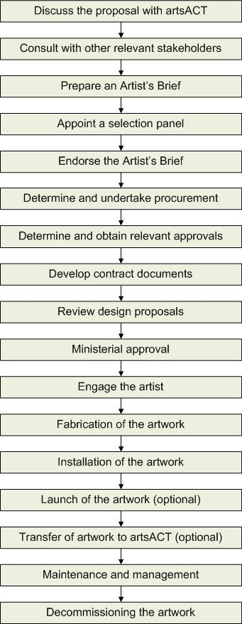
Steps in acquiring an existing artwork:
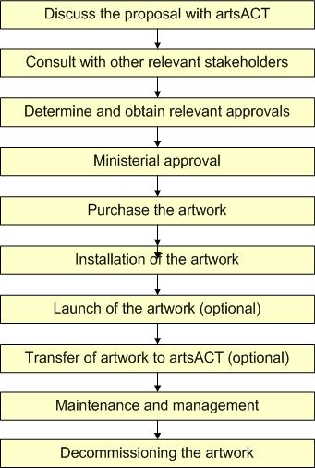

Case study: The commissioning of Icarus
This commission was by an important local artist, Jan Brown, to enliven a Civic location with a work of high artistic merit.
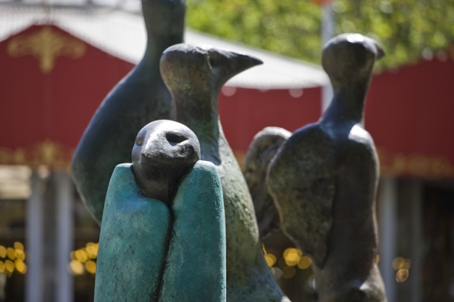
Jan Brown AM
Icarus, 2009
Bronze
Petrie Plaza/City Walk, Civic
Jan Brown is one of the Canberra region’s most important and influential sculptors. Trained in the United Kingdom under Henry Moore, she has inspired many generations of students and has exhibited nationally and internationally.
Brown was made a member of the Order of Australia and an Emeritus Fellow of the Australia Council for the Arts for her dedication to the visual arts.
Brown’s work can be seen in several important collections including the National Library of Australia, Parliament House, the Australian National University, the ACT Legislative Assembly and Artbank. A major collection of her work is held by the Canberra Museum and Gallery.
This sculptural group comprising Icarus may be seen as a delicate and witty reference to the city as home to many of the nation’s decision makers. While the myth warns of the folly of pride, Brown’s peculiar take on the story asks us to sympathise with the audacity of Icarus’s ambition and to accept the inevitable tragic conclusion to the tale.
A panel of art experts identified the Icarus series by Jan Brown for acquisition under the former Percent-for-Art Scheme in 2008. The works were scaled up and casts made at the Australian National University Sculpture Workshop and the finished pieces were cast at the Meridian Foundry in Melbourne.
For more information, visit www.arts.act.gov.au/public-art/icarus

Case study: The acquisition of Life Boat/Thuyen Cuu Roi
The ACT Government acquired this important artwork as it evokes a broad cultural context. Its location in Civic Library makes it a welcome beacon to the broad cultural community.
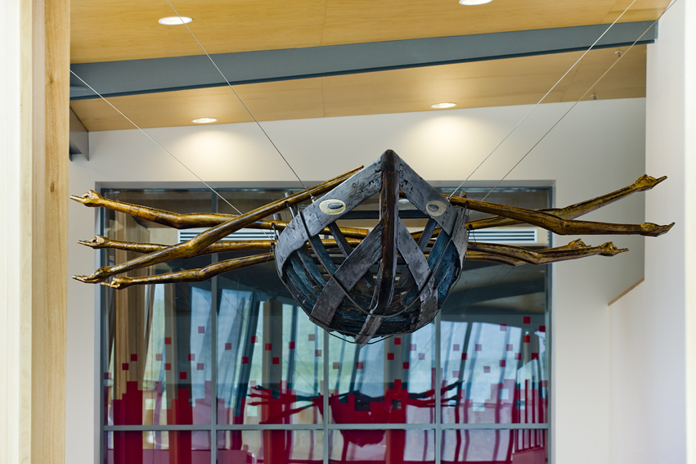

Nerine Martini
Life boat/Thuyen Cuu Roi, 2006
Wood, steel, lead, lacquer
Civic Library, Civic Square
Photo: Ben Wrigley (photohub)
Life Boat/Thuyen Cuu Roi is constructed from an old wooden boat which came from Hoi An in Vietnam. The arms/oars are carved from recycled timber and coated with lacquer using traditional Vietnamese techniques.
In the artist's words "Life Boat/Thuyen Cuu Roi seeks to embody ocean journeys of courage and compassion".
Acquired from Sculpture by the Sea.
For more information, visit www.arts.act.gov.au/public-art/life-boat-thuyen-cuu-roi

Contract considerations
Contracts should cover insurance responsibilities, copyright and reproduction arrangements, budget guidelines including a schedule of remuneration, decommissioning and relocation guidelines, ownership of maquettes, and other conditions as required.
Contracts should detail all services to be performed by the artist in the design, production, delivery and installation of a public artwork, as well as any additional services and considerations including the provision of a maintenance manual and warranty and defects liability periods.
Contact artsACT on (02) 6207 2384 for general information and advice on contracting public artwork commissions. For detailed contract advice contact the ACT Government Solicitors Office on (02) 6207 0666.

Artist’s care and skill
Contracts should require the artist to perform to the standard of care and skill expected of a person who regularly acts in the capacity in which the artist is engaged and who possesses the knowledge, skill and experience of a person qualified to act in that capacity; and produce the work using good workmanship and materials of good quality.

Insurance
Contracts should detail insurance responsibilities prior to acceptance of an artwork on site. The ACT Insurance Authority can provide advice in determining insurance requirements.

Transport and storage
Contracts should detail responsibility for transportation of an artwork to the installation site and for ensuring secure storage if site readiness occurs later than delivery.

Installation
The artist’s responsibility for the cost of artwork installation should also be included in the artist’s contract (and fee), as appropriate.

Defects liability and warranty
During the defects liability period, the artist will be required to fix defects in the artwork or else meet the costs the owner incurs fixing defects in the artwork and installation in accordance with the contract requirements.
The defects liability period is specified in the Artist Agreement.
The ACT Government requires artists to provide a general warranty period, consistent with the purpose of the work and nature of the materials used, against defects in design, manufacture, materials and workmanship.
The warranty should require that an artwork, under normal conditions at the site and provided the Territory undertakes the artist’s reasonable directions for maintenance as per the maintenance manual, will remain substantially in the form that it appeared at the date of acceptance, for the duration of the warranty period.

Decommissioning
Decommissioning and relocation clauses should also be included in the artist’s contract. The agreement should specify a particular period after which the condition and continued suitability of a work will be reviewed, and the work will be considered for removal from the ACT Government Public Art Collection.
Usually, the condition and continued suitability of an artwork will be reviewed ten years from the date of final completion and at five year intervals thereafter. The Territory may decide to decommission the artwork following review.

Ownership of artwork
Contracts should require the artist transfer title in artwork immediately upon acceptance.

ACT Government use of the work
ACT Government public artwork commissions must grant the Territory a perpetual, royalty free licence to reproduce, communicate, publish and broadcast images of the artwork in whole or in part in any publication or material (in any form whatsoever including electronic) that promotes, advertises or is in relation to the artist, the work, the site, the Territory, or Territory functions and activities.
Generally, ACT Government public artwork commissioning contracts should require an artist to seek written permission from the Territory if the artist wishes to create an identical or substantially similar work.

Intellectual property and copyright
Ownership of intellectual property rights (including copyright) in a commissioned public artwork generally remain vested in the artist. The artist is responsible for attributing all authors of any work that comprises part of the artwork, and for procuring the consent of said authors as appropriate.
Any display of the artwork should clearly identify the artist. Publications, representations or descriptions of the artwork, including audio, video, film, electronic or photographic means, should identify the artist as the creator of the work.
While intellectual property rights remain with the artist, a license may be negotiated as part of the commissioning contract to enable the commissioning party to reproduce, communicate, publish and broadcast images of the work.
The commissioning party would not usually acquire the rights to reproduce an artwork in a three-dimensional form or to use the image as a logo or branding. If this kind of use is intended, it should be outlined in the Artist’s Brief and negotiated with the artist. Such a requirement would impact on the artist fee and may involve royalties.
More information about artist’s moral and intellectual property rights protected under the Copyright Act 1968 (Commonwealth) is available on the Arts Law Centre of Australia website (www.artslaw.com.au/legal/information-sheets).

Installation
The site of public art on ACT Government land will be determined by the Territory, with consideration of advice from the artist on the preferred presentation of the artwork. The site may already be identified, and relevant information provided in the Artist’s Brief.
Artworks to be placed in urban open space require consultation with and approval from the City Services and Asset Acceptance Divisions of Transport Canberra and City Services in the early stage of the project.
Artworks to be installed near roadways will need approval from Roads ACT.
Artworks to be installed on National Capital Authority controlled or designated land will need approval from the National Capital Authority.
In order to seek and be awarded all approvals, considerable time must be allowed to thoroughly investigate all regulatory services and agreements. This may extend to pedestrian studies and roadside surveys.
Artist contracts should clearly outline the artist’s responsibility for transportation of an artwork to the installation site, and for ensuring secure storage if site readiness occurs later than delivery, as well as insurance prior to acceptance of the artwork on site. The artist’s responsibility for the cost of artwork installation should also be included in the artist’s contract, as appropriate.
The lighting of each public artwork will be considered on a case-by-case basis.
Each permanent public artwork must also be accompanied by a plaque (see Plaques).

Plaques
Each permanent public artwork must be accompanied by a plaque (preferably fabricated from cast bronze for durability).
The ACT Government Directorate that commissioned or acquired the artwork is responsible for the fabrication and installation of the plaque. In the case of donated artworks or private sector artworks accepted to be installed on ACT Government land, artsACT is responsible for plaque fabrication.
All plaques must contain the following information:
- ACT Government logo in the top right corner of the plaque.
- The artist’s name (surname in capital letters).
- The year the artist was born.
- Title of the artwork in bold.
- Year the artwork was fabricated.
- Medium/s (e.g. bronze, stainless steel, wood).
- A short artist’s statement of no more than 100 words.
- Name of the person who launched the artwork and the date. Alternatively, if the artwork was not officially launched, the date of installation.
For example:
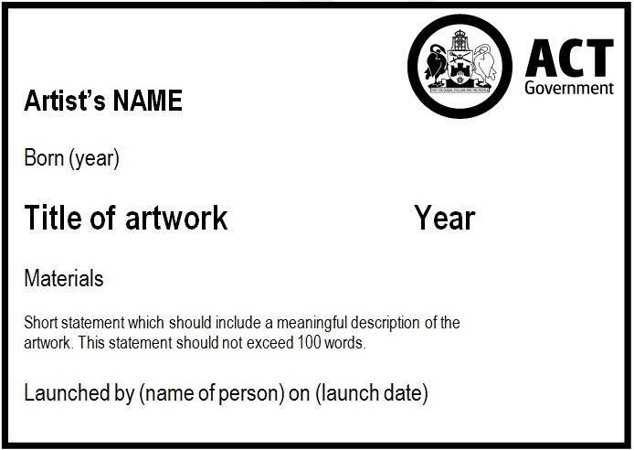
Standard dimensions for bronze accreditation plaques installed by artsACT are 230 x 160mm and are in landscape format.

Maintenance and collection management

Maintenance
It is important to determine early on in a public art proposal what the ongoing maintenance and durability requirements for the artwork will be.
Maintenance involves basic frequent activities such as cleaning of artwork surfaces and infrequent activities such as surface polishing. Maintenance also includes responding to vandalism and damage such as replacing broken components and removing graffiti and bill posters.
Conservation refers to major activities required to refurbish an artwork and may require removing the artwork from site. Conservation works may include the repainting of an artwork or the replacement of mechanical components. Specialised professional services are recommended for conservation work.
A public artwork must be able to be installed and subsequently maintained within available resources for the duration of its lifespan. As each artwork is different, some works will be more fragile than others and subsequently will require more maintenance and conservation work.
When commissioning an artwork, maintenance and management requirements should be considered when preparing the Artist’s Brief and when design proposals are being reviewed.
When acquiring an artwork, ongoing maintenance requirements should be discussed with the artist before the ACT Government accepts the artwork.
artsACT is able to advise on appropriate general maintenance procedures for artworks and can also provide advice regarding repairs and restoration of artworks, including details of specialist art conservators.

Responsibility for ongoing maintenance and management
The ACT Government Directorate responsible for commissioning or acquiring a public artwork is responsible for its ongoing maintenance, repairs and management, unless the artwork is formally transferred to artsACT. In the case whereby an artwork is transferred from another ACT Government Directorate to artsACT, an appropriate repairs and maintenance budget must be negotiated and transferred with the artwork.
For public artworks that have been commissioned/acquired by the private sector, the owner of the artwork is responsible for any repairs and maintenance.
For public artworks that have been donated to the ACT Government, once a gifted artwork has been formally accepted onsite artsACT is responsible for its long-term care and management (including decommissioning). artsACT is therefore responsible for any repairs and maintenance. Please note that the ACT Government may not be able to accept artworks which have high maintenance requirements.
It is suggested that dedicated funding be set aside for the maintenance of artworks each financial year with a more substantial amount being set aside at five year intervals for major activities required until decommissioning. The amount of funding required for maintenance will depend on the tasks set out in the maintenance manual provided by the artist at the installation of the work (practical completion). Some artworks will be more expensive to maintain than others. For example, those using water or electrical components can be very costly to maintain and the guaranteed availability of a suitable maintenance budget should be considered when commissioning an artwork.

Maintenance manual
Following successful completion of the fabrication and installation of the artwork, the artist should be required to prepare and provide to the owner a detailed maintenance manual, setting out the maintenance procedures to ensure continued integrity and safety of the work.

Defects liability and warranty
During the defects liability period, the artist will be required to fix defects in the artwork or else meet the costs the owner incurs fixing defects in the artwork and installation in accordance with the contract requirements.
The defects liability period is specified in the Artist Agreement.
Artists should note that there is both a defects liability period and a warranty period that will apply to the artwork once installed.
The ACT Government requires artists to provide a general warranty (recommended period is five years) against defects in design, manufacture, materials and workmanship. The warranty requires that artworks, under normal conditions at the site and provided the Territory undertakes the artist’s reasonable directions for maintenance as per the maintenance manual, will remain substantially in the form that it appeared at the date of acceptance, for the duration of the warranty period.

Safety and security
In addition to general wear and tear, all artworks in public places are exposed to the possibility of vandalism.
Agencies may consider a variety of preventative measures to minimise the likelihood of vandalism to artwork. These include increasing lighting, installing warning signage around the artwork, anchoring or securing the artwork to the ground, or locating the artwork in an open area that is visible to the general public.
Initiatives such as Closed-Circuit Television cameras (CCTV) and other forms of surveillance will be decided on a case-by-case basis in collaboration with the Justice and Community Safety Directorate, dependent on the artwork’s location and resources available.

Collection management
Once the artwork has been installed, the artist needs to submit the following information on each artwork for cataloguing purposes:
- Artist’s name.
- Title of work.
- Date of fabrication.
- Edition number (if relevant).
- Medium/s.
- A short artist’s statement (if not provided previously).
The artwork should then be added to the ACT Public Art Database (see ACT Public Art Database).

Decommissioning
Decommissioning is defined for the purposes of these guidelines as the formal process to remove public artwork from its active status, including (but not limited to) relocation, storage, sale, donation or disposal/destruction.
Each public artwork has a finite lifespan, depending on several factors, such as what it is made from and where it is located.
The condition and continued suitability of the artwork will be reviewed 10 years from the date of final completion and at five year intervals thereafter. The Territory may decide to decommission the artwork and remove it from the ACT Government’s public art collection after review. This includes artworks that have been donated to the ACT Government.
In some circumstances, it may be necessary to decommission an artwork before this 10 year period if one or more of the following criteria apply:
- The artwork requires a high level of maintenance and conservation, resulting in unsustainable asset management expenses.
- The artwork is irreparably damaged.
- The artwork endangers public health and safety, and remedy is impractical, not feasible or undermines the integrity of the artwork.
- The ACT Government is unable to reasonably guarantee the condition or security of the artwork in its current location.
- Continued display of the artwork undermines the artist’s intention.
- The site where the artwork is located is to be redeveloped, demolished or sold and it is not possible to incorporate the artwork into the redevelopment.
- The artwork is a forgery and violates copyright law (or any other law).
- The artwork has been in storage for five years or more.
Please note that the decommissioning process outlined above does not include privately owned public art on private land or memorials.
Some public art may also be included in the ACT Heritage Register. Contact the Heritage Unit within the EPSDD to discuss whether there are any constraints relating to heritage registration before decommissioning the artwork.

Case study: The decommissioning of LaserWrap
Geoffrey Drake-Brockman and Richie Kuhaupt
LaserWrap, 2004
20 x 120 metre green lasers with 30 degree spreader lenses in motorised projector boxes
Formerly located in Civic
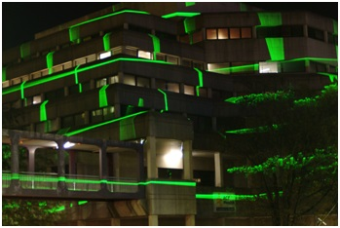
LaserWrap, by artists Geoffrey Drake-Brockman and Richie Kuhaupt, was installed onto the ACT Health building on the corner of Moore and Alinga Streets in 2004. The artwork was a series of 20 lasers housed in three motorised projector boxes which were located on the roof top of the GPO Building, Melbourne Building and Canberra House. LaserWrap has played an important part in the development of public art in Canberra and was one of the first visual art projects incorporating light and imagery onto a building.
The life expectancy of the work at installation was fifteen years. artsACT was advised by Morris Property Group that due to the redevelopment of Canberra House, the building was going to be demolished in November 2014. This building houses one of the three projector boxes and the proposed new building has not made allowances for a vantage point for the projector box. The existing three storey building will be replaced with a sixteen storey building.
In addition, an inspection of the artwork revealed that the lasers situated on the GPO Building were not operational. Due to the redevelopment of Canberra House and the failing technology, the artwork was decommissioned in November 2014.

Donating public art to the ACT Government
From time to time, the ACT Government is presented with a donation in the form of an existing public artwork or a proposal for a new public artwork.
The ACT Government appreciates the generosity of these proposed donations however may not be able to accept them all, particularly those that are not site-specific commissions. All donations and proposals are considered in a fair, transparent and consistent manner, acknowledging any cultural sensitivities and protocols.
Benefactors may also wish to contribute funds towards the commissioning of new artworks, or for the care and maintenance of existing artworks.
When considering donating a public artwork, please consider the following:
- The artwork must be an original work reflecting excellence in arts practice and be deemed to enrich the ACT Government public art collection.
- The size and theme of the artwork must be considered in the context of its proposed location.
- The artwork should promote social inclusion, diversity and artistic expression.
- The artwork must be made of robust materials capable of withstanding normal wear in a public place, as well as withstanding vandal attack.
- The artwork must promote diversity, equality and social inclusion in its design and commissioning in accordance with the ACT Government Procurement Value: Diversity, Equality and Inclusion as described in the Government Procurement (Charter of Procurement Values) Direction 2020.
- The artwork must comply with public safety requirements.
- The artwork must not raise security issues in accordance with crime prevention objectives.
- The artwork must not contain content that may offend and must meet any relevant Australian Government legislative requirements.
- The artwork must be able to be maintained within available resources for the duration of its lifespan.
- If the artwork relates to Indigenous cultures or sites, the artwork must be assessed by relevant Indigenous communities (or nominated representatives) as to its appropriateness for ownership by the ACT Government.
If you are thinking about donating an artwork to Latin American Plaza, please contact artsACT on (02) 6207 2384.
If you are considering donating an artwork for the National Arboretum Canberra, please contact the National Arboretum on (02) 6205 5082.
If you are thinking about donating an artwork to the Health Directorate, please contact the Canberra Hospital Foundation www.canberrahospitalfoundation.org.au

The process for donating a public artwork to the ACT Government is as follows:

Discuss the proposal with artsACT
Contact artsACT to talk about your intentions as a first step.
artsACT can provide assistance and advice on navigating the formal acceptance processes and can advise whether an artwork is likely to be deemed to enrich the ACT Government public art collection.
artsACT will liaise with Social Policy and Implementation in the Chief Minister, Treasury and Economic Development Directorate in relation to accepting donations of public art.
If the proposed location for an artwork is on urban open space, artsACT will consult with City Services and Asset Acceptance Divisions of TCCS. Proposed sites may be subject to a site suitability and risk assessment.
Consultation may also be required with Planning in EPSDD, who assess and determine Development Applications (DAs) for art proposals, and the Heritage Unit within the EPSDD if the artwork is to be located at a Heritage Place.
To make a time to discuss your proposal with artsACT, phone (02) 6207 2384.

Provide a written submission to artsACT
After first meeting with artsACT to discuss your proposal please provide a written submission for formal consideration, addressed to:
artsACT
Chief Minister, Treasury and Economic Development Directorate
GPO Box 158
Canberra ACT 2601
The submission should include the following:
- A location map showing the proposed site.
- Drawings of the proposed artwork showing materials, colours, and dimensions.
- Images of a maquette, digital representation, or sketch of the artwork.
- A description of the conceptual basis of the artwork (artist’s statement).
- Artist’s name and curriculum vitae including exhibition history (if applicable).
- Certification of the artwork components by an Australian certified professional engineer (Certificate of Structural Sufficiency if an existing work).
- A recent valuation of the artwork (if an existing work).
- Name of the artwork owner (if an existing work).
- Information on the preferred approach to the installation of the artwork including materials, layout, and lighting.
- Information about ownership, ongoing maintenance, and decommissioning requirements.
The written submission will be considered by senior officers in artsACT, including the Executive Business Manager. The individual or organisation commissioning or acquiring the artwork will be advised of the outcome in writing.

Ministerial approval
If artsACT supports a written submission, a recommendation will be made to the Minister for the Arts for final approval.
Written approval of proposed public artwork donations must be gained from the Minister for the Arts prior to gifting and installation. The Minister for the Arts reserves the right to decline the artwork if it does not meet the requirements of these guidelines or if the required funding for maintenance and collection management is not available.
If the artwork is to be located on urban open space, then approval must be sought from the Minister for Transport and City Services. Artwork proposals must be approved by the Minister prior to fabrication or acquisition and installation. The Minister for Transport and City Services reserves the right to decline artwork if it does not meet the requirements outlined in the ACT Government Public Art Guidelines or if the required recurrent funding for management and maintenance is not available.
The Territory may also refuse to accept the artwork should it not appear, on delivery to Canberra, as described in the approved submission.

Installation of the artwork
Installation of the artwork is at the cost of the donating party.
artsACT can assist with managing the installation of a donated public artwork on Territory land, in accordance with legislative requirements and in liaison with other relevant ACT Government agencies.

Launch (optional)
The donating party and/or the ACT Government may choose to hold an official launch for the artwork. A launch is an opportunity to formally acknowledge the artist, benefactor and other stakeholders involved in the donation.
The ACT Government may not have resources to assist with costs of launching all donated works.
If the artwork is to be launched by the Chief Minister or Minister for the Arts, artsACT can assist with preparing an event brief package for the Minister.

Management and maintenance
On formal acceptance of an artwork donated to the ACT Government, the work will become an asset of artsACT. Formal acceptance of a donated public artwork will be indicated in writing, including all necessary terms and conditions.
The Territory is responsible for the ongoing care and management of all formally accepted public artwork donations.

Decommissioning the artwork
ACT Government guidelines on decommissioning public artwork apply, regardless of whether an artwork was commissioned or acquired by a Government agency, via collaboration with the private sector or donated by a benefactor. An in-principle approach to decommissioning should be agreed on before any artwork is accepted into the ACT Government’s public art collection (see Decommissioning).

Steps in donating an artwork:
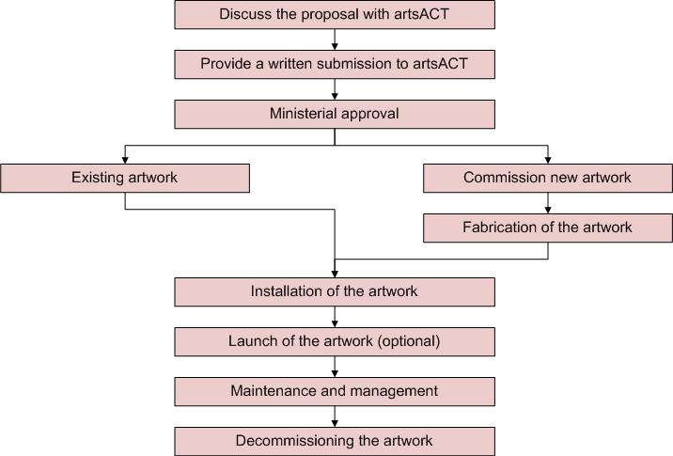

Case study: The donation of the statue of Confucius
A community and business initiative reflecting a significant Sister City Agreement and an important cultural exchange.
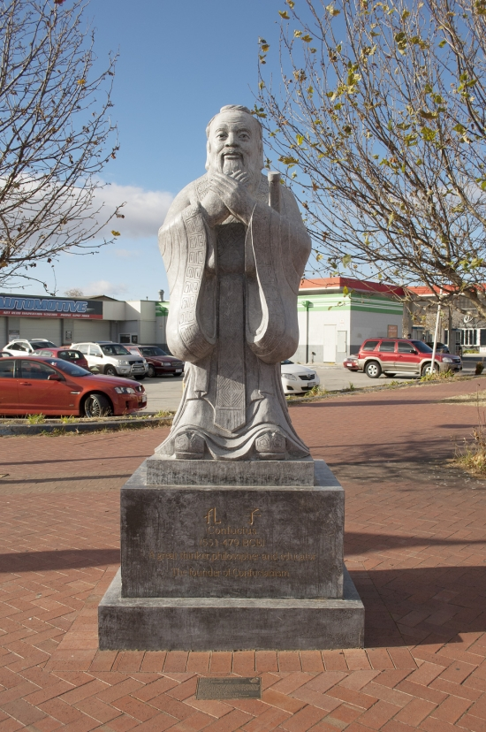

Jiaxiang Stone Carving Studio of Shandong
Statue of Confucius, 2010
Limestone
Corner Cape and Woolley Streets, Dickson
Confucius, a Chinese philosopher and teacher who lived in fifth century BC, has had a profound influence on Chinese culture and thought. This sculpture was carved in the birth place of Confucius, Qufu, Shandong Province, China.
Gifted to the people of Canberra by the Australian Confucius Research Society, in association with the Canberra Chinese Community Reparatory Committee of the Statue of Confucius, to celebrate the tenth anniversary of the signing of the Sister City Agreement between Canberra and Beijing.
For more information, visit www.arts.act.gov.au/public-art/confucius

Other gifts of cultural significance
From time to time, the ACT Government is presented with gifts or donations that do not fall within the definition of public art, but which are of cultural significance.
The ACT Government receives a number of generous offers of gifts of cultural significance. However, due to issues such as limited land availability, not all gifts of this nature can be accepted.
It is important that, before you offer the gift, you first discuss your proposal with artsACT to determine its suitability and relevance to the ACT.
To make a time to talk to artsACT, please telephone (02) 6207 2384.
artsACT will liaise with Social Policy and Implementation in the Chief Minister, Treasury and Economic Development Directorate in relation to accepting gifts of cultural significance. Proposed cultural gifts may also be referred to TCCS for consideration.
If you are thinking about donating an object of cultural significance to Latin American Plaza, please contact artsACT on (02) 6207 2384.
If you are considering donating an object of cultural significance to the National Arboretum Canberra, please contact the Forest Sculpture Garden on (02) 6207 8484.
If you are thinking about donating an object of cultural significance to the Health Directorate, please contact the Canberra Hospital Foundation (www.canberrahospitalfoundation.org.au).

Case study: The gifting of Fenix 2
A gift of cultural significance from the people and Government of Chile to the people and Government of Australia in recognition of business, government and community links between Australia and Chile.
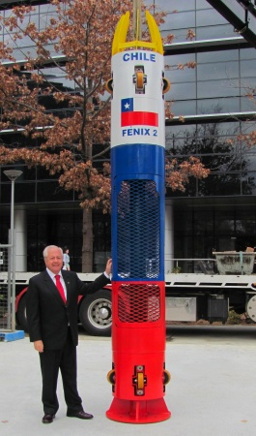
Fenix 2, donated 2011
Stainless steel
Latin American Plaza, off Marcus Clarke Street, Civic
Fenix 2 is a replica of the capsule that rescued 33 trapped miners from the San Jose mine in the Atacama Desert, Chile in October 2010.
Seventeen days after the mine collapse, the Australian rescue drill team penetrated the cavern where the miners were trapped. On 14 October 2010, after 69 days underground, the first of the miners was brought to the surface.
Fenix 2 ferried each miner through approximately 623 metres of rock, each journey taking 15-20 minutes.
For more information, visit www.arts.act.gov.au/public-art/fenix-2https://www.arts.act.gov.au/public-art/fenix-2

Memorials with an artistic element
Memorials differ from public art because the main intent of the object is to commemorate either a person or an event.
Although not defined as public art, several memorials in the ACT have been designed and constructed by artists and are in public places. Examples of these are the ACT Bushfire Memorial, the Kambah Firestorm Storytree Memorial, the Woden Flood Memorial, and the ACT Memorial.
The commissioning of a memorial needs to be dealt with sensitively and will involve consultation with stakeholders and the community.
All enquiries regarding the commissioning of memorials on ACT Government land should be directed to City Services and Asset Acceptance Divisions of TCCS by phoning Canberra Connect on 13 22 81. TCCS will liaise with artsACT if an artistic element is being considered.
Please note the following:
- TCCS specifies that there are to be no memorials to private individuals or animals on ACT public land.
- Plaques should not carry the text ‘in memoriam’ or similar.
- The Territory may decide to decommission a memorial after ten years.
For information on roadside memorials, please refer to the ACT Roadside Memorials Policy available on the TCCS website www.cityservices.act.gov.au/roads-and-paths/policies-reports/roadside_memorials_in_the_act
Please note that if you are thinking about commissioning or donating a memorial to the Health Directorate, please contact the Canberra Hospital Foundation (www.canberrahospitalfoundation.org.au).

Case study: The commissioning of the ACT Memorial
The ACT Memorial was commissioned by the ACT Government to honour those who have had an association with the ACT and who have served their country in war, conflict, peacekeeping, and humanitarian missions.
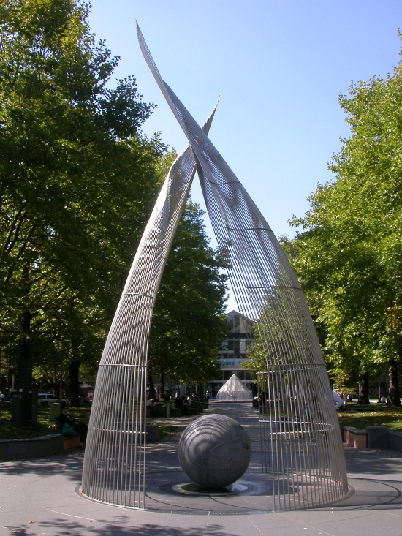
Matthew Harding
ACT Memorial, 2005
Stainless steel, granite, optic fibres and lighting
Ainslie Avenue median, London Circuit, Civic
The Artist’s Brief for the Memorial was developed through a working party of members of the Veterans Council, ACT Heritage Library and ACT Government officers. Canberra artist Matthew Harding designed and created the Memorial.
The Memorial incorporates representations of the world and the overarching goal of peace, providing a quiet place for remembrance and contemplation.
The Memorial has two parts: the physical Memorial located opposite Civic Square on London Circuit; and an active website containing a database of names and information about the people honoured by the Memorial. As the Memorial has no defined campaign or field of action yet responds to all those who have an association with the ACT and have served, and in some cases died, the website is an ever evolving and ongoing record of service, from the time of Federation to contemporary service in Afghanistan and other peace keeping missions.
For more information, visit www.arts.act.gov.au/public-art/act-memorial

Private sector public art on ACT Government land
The ACT Government encourages the private sector to commission, acquire and install public art on both ACT Government and private land.
The ACT Government is committed to improving and supporting the development of high quality design in the built environment in Canberra. Major building and infrastructure projects are one of the most influential elements shaping our city’s vibrancy. Consider integrating public artwork into a site as early as possible to get the best outcome.
Public art can augment building and landscape design in a range of ways. An artist-planner may be engaged to provide input into project designs or artists may be engaged to collaborate with other design professionals during project development.
When commissioning or acquiring an artwork for location in the public arena, please consider the following criteria:
- The artwork should reflect excellence in contemporary arts practice.
- The artwork should promote social inclusion, diversity, and artistic expression.
- The artwork must be made of robust materials that will withstand weathering and normal wear in a public place as well as vandal attack. Commonly used materials are stone, bronze, or stainless steel.
- The size and theme of the artwork should be considered in the context of its proposed location and the scale of the surrounding landscape or built form.
- The artwork must promote diversity, equality and social inclusion in its design and commissioning in accordance with the ACT Government Procurement Value: Diversity, Equality and Inclusion as described in the Government Procurement (Charter of Procurement Values) Direction 2020.
- The artwork must comply with public safety requirements.
- The artwork must not raise security issues in accordance with crime prevention objectives.
- The artwork must not contain content that may offend and must meet any relevant Australian Government legislative requirements.
- If the artwork relates to Indigenous cultures or sites, the proposed work should be assessed by relevant Indigenous communities (or their nominated representatives) as to its appropriateness.
These guidelines have been developed to ensure private sector public artworks proposed for location on Territory land meet appropriate standards of aesthetic quality and public safety.

Discuss the proposal with artsACT
As a first step, discuss your ideas with artsACT.
artsACT can assist in developing proposals and provide information and advice on ACT Government approvals that may be required.
Depending on the proposed scope, location and ownership of the public art, development approvals may be required from EPSDD, Roads ACT, other areas of the ACT Government or bodies such as the National Capital Authority.
If the artwork is to be in urban open space, artsACT will consult with the City Services and Asset Acceptance Divisions of the TCCS. Proposed sites may be subject to a site suitability and risk assessment.
Artworks of a temporary nature may be considered for display in some locations. Proposals for short-term display should also be discussed with artsACT.
To make a time to discuss your public art proposal with artsACT, please phone (02) 6207 2384.

Provide a written submission to artsACT
It is suggested that a design proposal be submitted to artsACT for review. This should occur early to allow feedback to be considered during the development of the public artwork.
Please provide a written public art proposal for formal consideration, addressed to:
artsACT
Chief Minister, Treasury and Economic Development Directorate
GPO Box 158
Canberra ACT 2601
The submission should include the following:
- A location map showing the proposed site.
- Drawings of the proposed artwork showing materials, colours, and dimensions.
- Images of a maquette, digital representation, or sketch of the artwork.
- A description of the conceptual basis of the artwork (artist’s statement).
- Artist’s name and curriculum vitae including exhibition history (if applicable).
- Name of the artwork owner (if an existing work).
- Information on the preferred approach to the installation of the artwork including materials, layout, and lighting.
- Information about ownership, ongoing maintenance, and decommissioning requirements.
The written submission will be considered by senior officers in artsACT, including the Executive Branch Manager. The individual or organisation commissioning or acquiring the artwork will be advised of the outcome in writing.

Ministerial approval
As artsACT consider written submissions they will be forwarded to the Minister for the Arts for final approval.
The Minister for the Arts reserves the right to decline the artwork if it does not meet the requirements of these guidelines or if the required recurrent funding for maintenance and management is not available.
If the artwork is to be located on urban open space, then approval must be sought from the Minister for Transport and City Services. Artwork proposals must be approved by the Minister prior to fabrication or acquisition and installation. The Minister for Transport and City Services reserves the right to decline artwork if it does not meet the requirements outlined in the ACT Government Public Art Guidelines or if the required recurrent funding for management and maintenance is not available.

Fabrication of the artwork
If an artwork is to be located on Territory land, the artist must:
- Provide design advice on the preferred approach to the installation of the artwork including materials and layout.
- Provide design documentation for fabrication including specifications, plans, elevations, construction details and fabrication notes as required.
- Provide a final design report including an artist’s statement describing the proposed works.
- Arrange certification of the artwork components by an appropriately qualified Australian certified professional engineer (e.g. Certificate of Structural Sufficiency).
- Fabricate, insure, and freight the artwork to Canberra.
- Insure and provide storage prior to installation if required.
These costs should be budgeted for in all proposals and contract documentation.
The Territory may refuse to accept an artwork should it not appear, on delivery to Canberra, as described in the approved submission.

Installation of the artwork
artsACT will assist with managing the installation of private sector artwork on Territory land, in liaison with other relevant ACT Government agencies (see Installation).
Installation will be managed at the cost of the individual or organisation that commissioned or acquired the artwork.

Maintenance and management
For public artworks that have been commissioned or acquired by the private sector and located on Territory land, the owner of the artwork is responsible for any repairs and maintenance (see Maintenance and collection management).

Decommissioning the artwork
For artworks located on Territory land, the ACT Government’s guidelines on decommissioning an artwork will apply (see Decommissioning). Ensure the artist is aware of decommissioning guidelines for public art prior to acquisition.
A decommissioning and relocation clause should be included in the artist’s contract. The agreement should specify that the condition and continued suitability of the artwork will be reviewed 10 years from the date of final completion and at five year intervals thereafter. Specifying an expected lifespan in this way respects the artist’s moral rights whilst acknowledging the changing needs of our city and our community. This means that a process by which an artwork can be disposed of at the end of its life is agreed when the artwork is first commissioned.
Other useful information including advice on consulting with stakeholders, preparing an Artist’s Brief, reviewing design proposals, and developing contract documents can be found under ACT Government commission and acquisition processes.
Steps in locating a private sector artwork on ACT Government land:
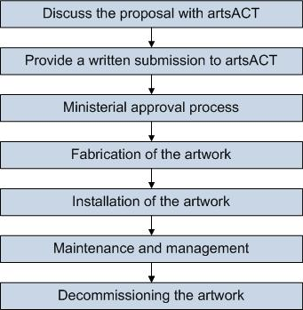

Case study: Resilience – a private sector and ACT Government collaboration
Originally commissioned to be installed within the building curtilage, the artwork was approved through a formal lease to sit in public space on Territory land in City Walk to provide greater public access and viewing.
The location of this privately owned work on public land has been a positive outcome for the commissioning agents, Consolidated Builders Ltd, the artists and the ACT community who can enjoy the work in the public domain.
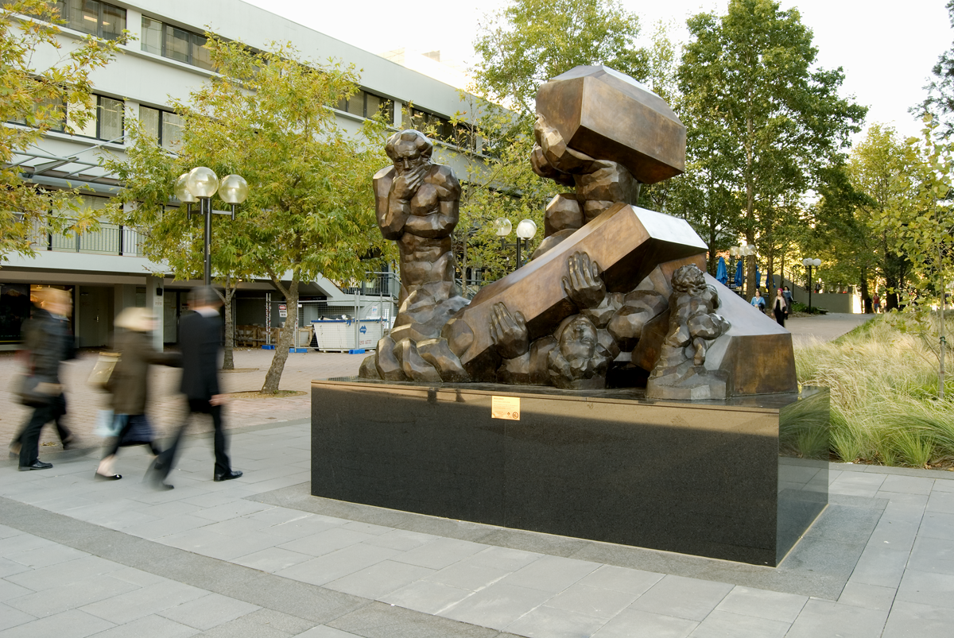

Ante Dabro
Resilience, 2008
Bronze
Corner of Binara Street and City Walk, Civic
Commissioned by Consolidated Builders Ltd, Resilience is on loan to the ACT Government.
For more information, visit www.arts.act.gov.au/public-art/resilience

Private sector public art on private land
The ACT Government encourages the private sector to commission and acquire public art on both ACT Government and private land.
While privately owned artwork located on private land is the business of the land owner or developer, the ACT Government can assist with advice about regulations and best practice for engaging and working with artists to deliver a public art project.

Discuss the proposal with artsACT
As a first step, discuss your ideas with artsACT.
Depending on the proposed scope and location of the artwork, development approvals may be required. artsACT can help with identifying and navigating necessary approval processes.
artsACT can also advise on a range of issues, including:
- Preparing an Artist’s Brief.
- Advice on appropriately skilled artists.
- Reviewing design proposals including materials robust enough to withstand normal wear in a public place as well as withstanding vandal attack, and public safety requirements.
- Developing contract documents including advice on insurance responsibilities, copyright and reproduction arrangements, defects liability and warranty, and decommissioning and relocation.
- Certification of the artwork components by an appropriately qualified Australian certified professional engineer (Certificate of Structural Sufficiency).
- Installation and launch.
- Ongoing maintenance and repair.
To make a time to discuss your public art proposal with artsACT, please phone (02) 6207 2384.

Case study: Time Thief - a private artwork commissioned for private land
This is a private artwork, commissioned for private land accessible to the public.
New Acton is a new and exciting arts precinct in Civic. One of the directors of the Molonglo Group bought an old train station clock in Paris and commissioned a local Canberra artist to create an artwork for the public domain of New Acton.
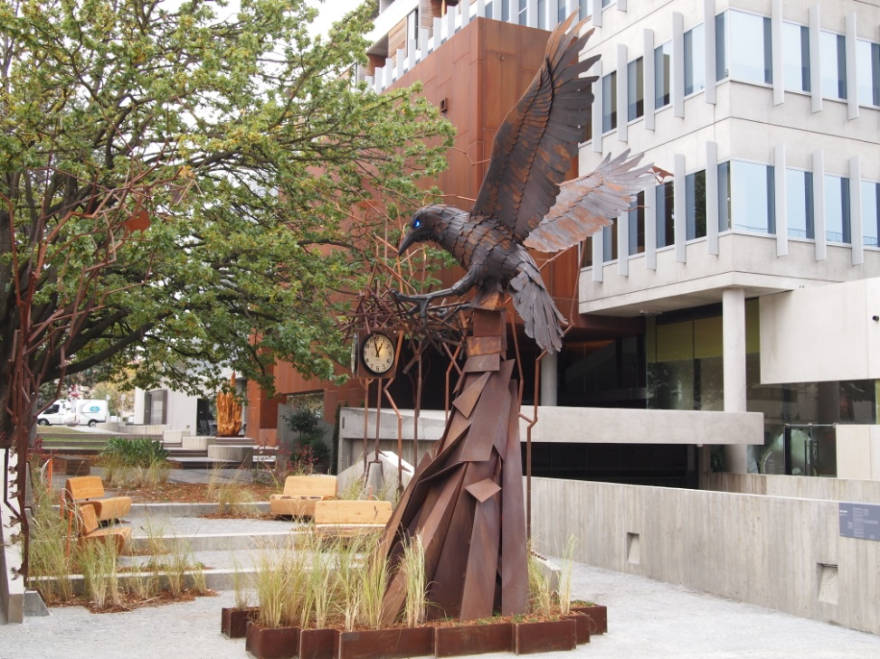

Robin Blau
Time Thief, 2011
Lyten steel, train station clock
New Acton Precinct
Commissioned by the Molonglo Group for the New Acton Precinct.
For more information, visit www.molonglogroup.com.au/art/time-thief

Temporary and community art on ACT Government land
Temporary art refers to public artworks designed and created for a short life span. The duration of a temporary public artwork may be as brief as minutes, hours, or days or as long as weeks or months.
For the purpose of the ACT Government Public Art Guidelines, this means:
- artworks intended to have a lifespan of less than one year including but not restricted to performance, ephemeral and time-based sculptural installations, temporary installations of durable artworks, light art, sound art, video projections, poster art, broadcast art and other media arts, flash mobbing and/or moveable artworks; and
- community artworks and murals that are part of the ACT Government’s Legal Graffiti Art Site program, where the artwork is intended to be removed, replaced or refreshed at some stage to ensure the artwork’s relevance to its site as well its ongoing condition.
The ACT Government encourages ephemeral and temporary art in public places. If you are planning a project that involves a temporary public art installation, you should consider the following:
- Does the artwork comply with public safety requirements?
- Does the artwork promote diversity, equality, and social inclusion?
- Does the artwork raise security issues in accordance with crime prevention objectives?
- Does the artwork contain content that may offend? Do you need a permit? If you are unsure, please contact the City Services team within TCCS via Canberra Connect on 13 22 81.

Community art
For the purpose of these guidelines, community art refers to public artwork of community significance that involves the active participation of community members in its design or creation, often facilitated by an artist or a community arts worker. Community art may be temporary, semi-permanent or permanent.
Community art, including community murals, can help to brighten and enrich public spaces and build a sense of community ownership and pride. Community art may have the effect of making public places more attractive and less prone to vandalism.
Benefits of community art projects include:
- Reduction and control of graffiti at specific community locations.
- Enhanced understanding of the roles and values of community groups in each location.
- Reduction of vandalism to community assets.

Community art sites can feature semi-permanent works or murals that may be in the graffiti art style.
Community artworks and murals are usually intended to be removed, replaced or refreshed at some stage, with consideration of the artwork’s relevance to its site as well its ongoing condition.
Community art murals are commissioned by TCCS in areas deemed appropriate. The Police, City Rangers and contracted graffiti removers are notified that the particular site has been given the status of a legal wall and artists are given approval to paint there.

Legal Graffiti Art Site program
The TCCS administers the Legal Graffiti Art Site Program.
Legal graffiti art sites are ACT Government assets in urban open spaces (e.g. skate parks, underpasses and toilet blocks), identified and demarcated in accordance with the Graffiti Guidelines as sites available for ongoing use by graffiti writers/artists for the development of artwork in the graffiti style or for general graffiti writing. The work featured at these sites may change.
Legal graffiti art sites differ from community art sites (murals), in being available for ongoing work by graffiti artists. The Police, City Rangers and contracted graffiti removers are notified that the particular site has been given the status of a legal wall and the artists are given approval to paint there.
The Graffiti Guidelines are available on the TCCS website https://www.cityservices.act.gov.au/public-land/public-spaces-and-facilities/graffiti or by phoning Access Canberra on 13 22 81.

Case study: Sir Robert Menzies and the guerrilla knitters

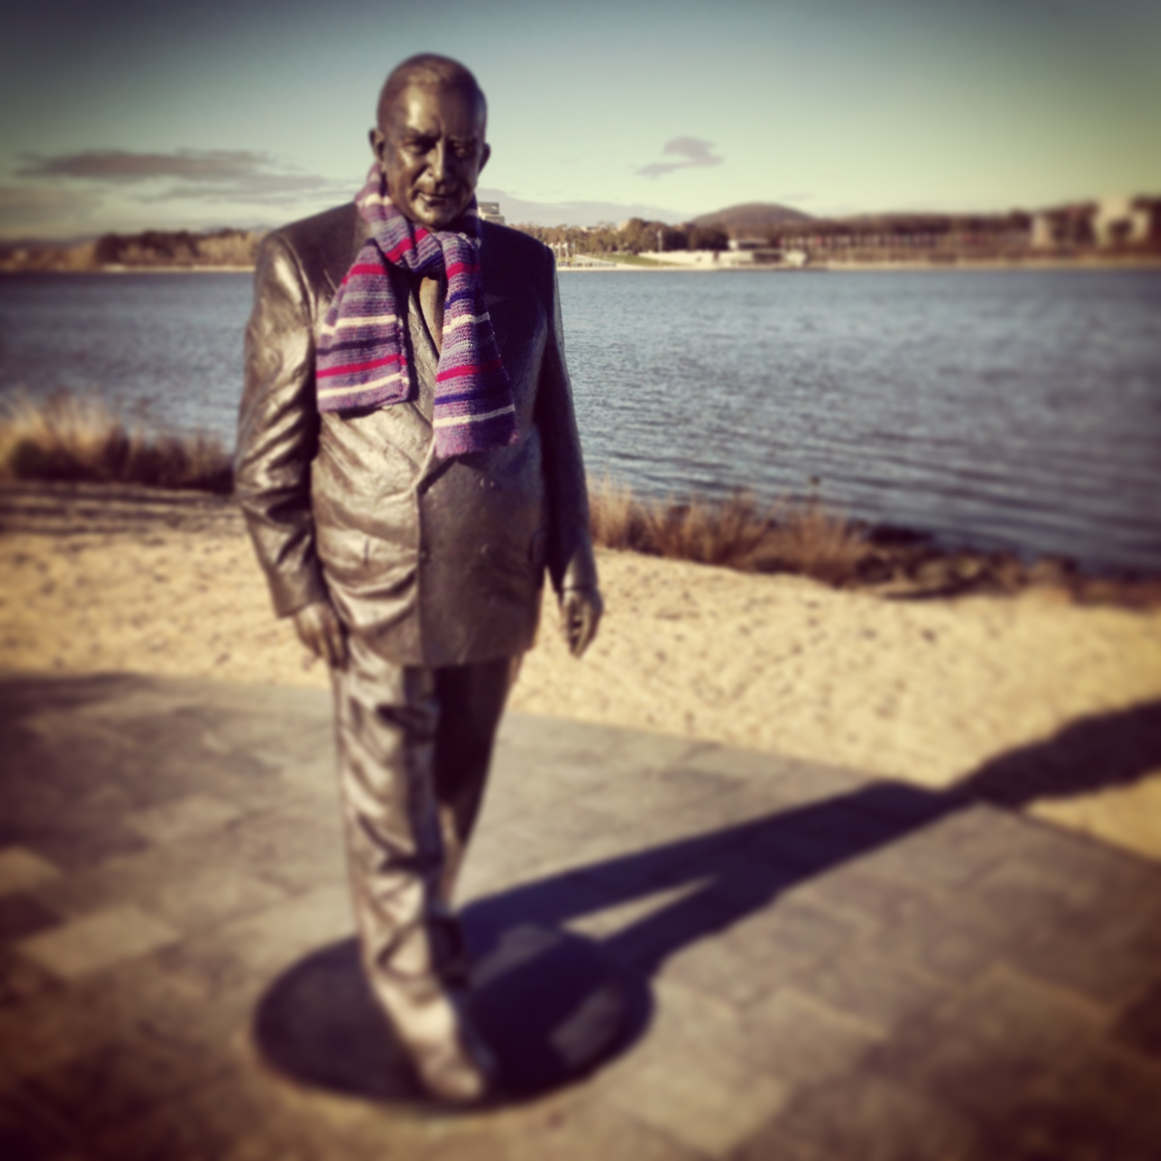

Peter Corlett
Sir Robert Menzies, 2012
Bronze (wool added)
Menzies Walk, Commonwealth Park, Canberra City
Photo: Richard Baz
During winter in July 2013, local guerrilla knitters made scarves and beanies for well-known sculptures around Canberra including Poet’s Corner poets Judith Wright, A.D. Hope and David Campbell; Prime Minister John Curtin and Treasurer Ben Chifley; and Sir Robert Menzies.
For more information, visit www.arts.act.gov.au/public-art/sir-robert-menzies

The ACT Public Art Database
All ACT Government public artworks should be listed in the ACT Public Art Database at www.arts.act.gov.au/public-art. This ensures the ACT Government public art collection is accessible to as many people as possible.
The ACT Public Art Database is managed by artsACT and located within the artsACT website. To have a work included in the database, contact artsACT on (02) 6207 2384.
You will need to provide artsACT with:
- A recent high resolution JPEG of the artwork (between 500KB and 4MB).
- The artist’s name.
- The title of the artwork.
- The year the artwork was fabricated.
- The year the artwork was installed (if different to fabrication date).
- Mediums used in the fabrication (e.g. bronze, stainless steel, wood).
- Details of who funded the artwork.
- Details of who owns the artwork (if different to the funder).
- The exact location of the artwork, including Google maps longitude and latitude coordinates if possible.
- A short description of the artwork.
- The name of the persons who launched the artwork and the date, if relevant.
If possible, please provide this information before the artwork is launched.
This information can be emailed to artsACT@act.gov.au
Although there is no requirement to do so, artsACT is happy to include private sector public artworks on the ACT Public Art Database at no cost by following the same process as above. The database entry will clearly state who owns the artwork.

Appendix A

Glossary of terms
The following are a list of terms used, and their meaning within the context of the ACT Public Art Guidelines.

Acquired public art / Public art acquisition
An existing artwork that has been purchased ‘off the shelf’ (e.g. from an artist, gallery, exhibition or catalogue) with the specific intention of being sited or staged in the physical public domain and accessible by the public.

ACT Government public art collection
The ACT Government’s public art collection is a diverse, growing and dynamic collection of art works and encompasses all works of public art that are owned by the ACT Government.
Many ACT Government agencies commission or acquire new work as a part of the services they provide to our community. Whilst this activity often occurs in the context of new construction it may also occur during building or public place refurbishment, to mark a special anniversary, or to commemorate a figure who has made an important contribution to our region.

Bequest
An existing artwork that has been privately or publicly donated via a will.

Commemorative work
See Memorial.

Commissioned art
A site-specific artwork commissioned from an artist that is inspired by and responds to its urban design and landscape context and its community, cultural and historical context. Generally of high value (monetary and cultural), commissioned art may be temporary, semi-permanent or permanent.

Community public art
Public artwork of community significance involving the active participation of community members in its design and/or creation and often facilitated by an artist or a community arts worker. This includes community murals. The artwork may be temporary, semi-permanent or permanent.

Deaccessioning
See Decommissioning.

Decommissioning
Decommissioning is the term used for permanent removal of a work of art from a public art installation or collection. Decommissioning is a dynamic element of all public art collections, and each artwork should be reviewed periodically to determine its relevance and context in relation to location and the collection as a whole.

Donated art
Usually an existing artwork by a recognised artist that has been given to the ACT Government via private or public donation (e.g. from an artist, individual, gallery, business or community group) and that is deemed to enrich the ACT Government Public Art Collection.

Gift
See Donated art.

Graffiti
By definition, graffiti is deemed as writing or drawings scribbled, scratched, or sprayed illicitly on a wall or other surface in a public place. Graffiti may express social and political messages and a whole genre of artistic expression is based upon spray paint graffiti styles. For the purpose of this document, graffiti is considered to be unsanctioned, as opposed to street art (see definition below).

Indoor art collection
Moveable artworks displayed inside ACT Government buildings and facilities. Each agency is responsible for their own indoor art collection

Loaned art
An existing artwork that is on either temporary or permanent loan to the ACT Government by the artist or the owner.

Memorial
For the purposes of the ACT Government Public Art Guidelines, a memorial is defined as an object that serves as focus for commemorating a person or event. This object may be site specific, have cultural significance and artistic merit; however, a memorial is not usually considered to be public art.

Object of cultural significance
Moveable items of cultural significance, often community or diplomatic gifts, which are displayed inside ACT Government buildings and facilities.

Public art
Defining public art is the subject of ongoing discussion and debate. According to the ACT Government Planning and Development Regulation 2008, a public artwork is defined as “an artwork to be displayed in a place open to and accessible by the public.”
The term public art in the context of these guidelines refers to works of art in any media that have been planned and executed with the specific intention of being sited or staged in the physical public domain, usually outside and accessible to all. Public art includes, but is not limited to, projects that:
- Consider the social and physical context of the site.
- Engage with or enhance the public perception of a place.
- Enliven our public places, precincts, buildings, and meeting places.
- Are located in places that are open and accessible to the public.

Street art
Street art is usually created in public spaces — that is, ‘in the streets’. The term can include (but isn’t limited to) traditional graffiti artwork, sculpture, stencil graffiti art, sticker art, paste ups and street poster art, video projection, art intervention, guerrilla art and street installations (two or three dimensional). Typically, the term street art is used to distinguish contemporary artwork in a public space from territorial graffiti and vandalism. For the purpose of this document, the term street art refers to sanctioned art activities which may or may not be in a graffiti style.

Tagging
Personalised signature of a graffiti artist. Tagging may or may not have artistic merit. For the purpose of this document, tagging is considered to be unsanctioned, as opposed to ‘street art’ (see definition above).

Temporary art
Artistic works designed and created for a short life span.

Appendix B

Related policies and guidelines
- ACT Government, Planning and Development Regulation 2008 www.legislation.act.gov.au/sl/2008-2/default.asp
- artsACT, Statement of Ambition 2021-2026 www.arts.act.gov.au/policy/statement-of-ambition
- artsACT, Public Art Guidelines - Latin American Plaza: For Acquisitions or Commissions Donated by Latin American Countries (first published 2011, revised 2013, available on request)
- Australian Government, National Memorials Ordinance 1928 www.comlaw.gov.au/Details/F2009B00009
- National Capital Authority, Guidelines for Commemorative Works in the National Capital (2002) www.nca.gov.au/planning/plans-policies-and-guidelines/guidelines-commemorative-works-national-capital
- National Association for the Visual Arts, The Code of Practice for the Professional Australian Visual Arts, Craft and Design Sector (2014) https://visualarts.net.au/code-of-practice
- ACT Roadside Memorials Policy www.cityservices.act.gov.au/roads-and-paths/policies-reports/roadside_memorials_in_the_act
- Transport Canberra and City Services Graffiti Guidelines www.cityservices.act.gov.au/public-land/public-spaces-and-facilities/graffiti

